Project 1: Life Expectancy (WHO)

Statistical Analysis on factors influencing Life Expectancy

By Suchismita Moharana and Jamie Vo

## Introduction

Immunization has received national attention concerning the risks and dangers of receiving vaccines. The World Health Organization, and many other institutions, studied the factors that would affect life expectancy, with the exception of including immunizations. By including three vaccines (Hepatitis B, Polio, and Diphtheria), the observational study determines whether the variables play a significant role in reducing or increasing life expectancy.

## Data Description

The Global Health Observatory (GHO) data repository under World Health Organization (WHO) keeps track of the health status as well as many other related factors for all countries. The datasets are made available to the public for the purpose of health data analysis. The dataset related to life expectancy, health factors for 193 countries has been collected from the same WHO data repository website and its corresponding economic data was collected from the United Nation website. The dataset used for this project is available on [kaggle’s site](https://www.kaggle.com/kumarajarshi/life-expectancy-who?select=Life+Expectancy+Data.csv).

The original dataset has 2,938 observations and 22 variables. For an in-depth explanation of each variable, please visit the appendix. We have considered observations for 2014 for analysis of this project which has 183 records. The data has been reduced to only 2014 for consistency considering health climates have the ability to change year over year. The final dataset utilized in the analysis mapped below contains 183 observations with 21 variables, omitting year and country. Country is omitted due to it being unique for each observation.

## Exploratory Data Analysis (EDA)

Initially, the data has many missing data points, primarily from the population and GDP columns. Removing all observations with missing data resulted in ~30% loss of the dataset, hence the replacement of nulls with the mean of each variable is opted for.

The EDA caused questions to arise concerning the data collection methods for specific variables. Percentage expenditure (expenditure on health as a percentage of Gross Domestic Product per capita(%) ) has values ranging from 0 to 19480. Since this is a percentage value, it should not go beyond 100. And in practical scenarios, no country spends 100% of its GDP on healthcare.

Population is a right skewed field and removed because it has a high number of missing values and it does not appear to have any relationship with life expectancy. Adult mortality rates appear to have strong negative correlation with life expectancy whereas schooling and income composition show a clear positive linear trend for life expectancy. Developed countries have a higher mean of life expectancy than a developing country.

In analyzing the immunizations (Hepatitis B, Diphtheria, and Polio), there appears to be no linear relationship with life expectancy. Initially appearing to have a quadratic relationship. Despite this more precise model, the ability to explain the data is less than 15%. Due to this, the expectation of immunizations having a significant impact on life expectancy is low.

## Objective 1

### Restatement of Problem and the overall approach to solve it

The primary goal of the analysis is to determine key variables that attribute to life expectancy. For model one, in addition to determining what key factors affect life expectancy, interpretability is kept in mind. Model 2 focuses specifically on predictability, with the concern for explanation to be reduced. Finally, model 3 utilized a nonparametric model to determine statistically significant variables.

After completing the EDA for the data set, forward, backward, stepwise, and lasso techniques were used to narrow down the variables and determine significance. Stepwise and backward resulted in the same variables, hence, moving forward, only stepwise will be referred to. Lasso returned a number of variables that were not in the linear regression stepwise. It was ultimately determined that Lasso’s only significant return variable is income and composition of resources, considering that it trends towards zero.

|  |  |
| --- | --- |
| Stepwise/Backward | Lasso |
| * StatusDeveloping * Adult.Mortality * infant.deaths * under.five.deaths * Total.expenditure * Diphtheria * HIV.AIDS * Income.composition.of.resources | * Income.composition.of.resources * StatusDeveloping * Adult.Mortality * Alcohol * under.five.deaths * Total.expenditure * Diphtheria * thinness.5.9.years * Income.composition.of.resources |

In running the selections above, collinearity is eliminated and not a concern with the remaining models.

The higher complexity model consisted of three phases:

1. Adding in additional variables that were considered to be significant from Lasso and stepwise, but did not make it into the final model
2. Adding in interaction terms

In running the different models and comparing the metrics, the model with the greatest ability to predict data was selected as the final model.

Non-parametric models were tested (KNN, decision tree, random forest). KNN is dependent on the value of selected K and results are not consistent. Because this is dependent on the data set split (Train / Test) and results would be dependent on the values of nearest neighbours. While it can give surprisingly accurate results, the error rate can be high as well sometimes. Decision Tree methods need tree pruning to provide the optimal result whereas a random forest model handles it on its own. Random forest was selected as the method due to KNN proving to be an inappropriate model. Rather than selecting only decision trees over random forest, random forest does not require pruning and accounts for the potential of overfitting.

### Model Selection

#### Type of Selection

The selection types tested are stepwise, forward, lasso, and manual. Lasso, followed by stepwise and forward selection had the lowest to highest number of variables (respectively), that were considered to be significant. As anticipated, forward resulted in the highest number of variables since it continues to add variables on top of the existing model, stepwise has less variables as it adds and removes variables as they become insignificant, and lasso results in the lowest amount due to its trend towards zero. Lasso ultimately was narrowed down to only one variable considering the coefficients of the variable are less than 0.10.

#### Checking Assumptions

Linear regression requires 4 assumptions to be met in order for regression to be applied properly. Available in the appendix linearity, normality, and constant variance are met for all 3 models. In terms of independence, since all models were subjected to a selection method, any collinearity has been eliminated in the process. This is due to the fact that any collinearity would cause all but one of the variables to be insignificant, resulting from being eliminated from the final model.

Outliers were present in the data, but not to an extent where the models were greatly skewed. Reviewing the Cook’s D plots for all 3 models, none exceed the scale of 10. All three plots have Cook’s D below 1, causing the concern for outliers to be eliminated for linear regression.

#### Compare Competing Models

Lasso was run to determine the most significant variables, which was determined to only be income and composition of resources. Stepwise resulted in a number of variables, followed by forward which had a significantly greater number.

All models were run to collect metrics in table 1, below. In addition, they were trained on a training set before using the model to predict a test set that was split 80/20. Reviewing the scores MSE, CV, AIC, and BIC, the trend follows lasso, forward and stepwise, respectively in decreasing order. This indicates that the stepwise selection model is considered to be the most accurate model of the three, and lasso being the least accurate.

The adjusted R^2 indicates that the stepwise and forward selection models are able to explain similar degrees of the data (0.86, 0.85, respectively), while lasso has a significant drop (0.73). After testing with the split data set, forward and stepwise do share similar accuracy metrics, with only 0.01 difference. Reviewing the accuracy score for lasso is higher than anticipated when looking at the R^2 models, having only a 0.03 difference to stepwise.

|  |  |  |  |  |  |  |
| --- | --- | --- | --- | --- | --- | --- |
| **Models** | **MSE** | **CV** | **AIC** | **BIC** | **AdjR2** | **Accuracy** |
| forward | 3.35 | 14.14 | 464.26 | 534.87 | 0.85 | 0.78 |
| stepwise | 3.29 | 11.71 | 447.13 | 482.44 | 0.86 | 0.79 |
| lasso | 4.34 | 19.84 | 549.09 | 558.72 | 0.73 | 0.76 |

Table 1: Linear regression metrics for forward, stepwise, and lasso selections.

This indicates that although stepwise resulted in more promising metrics on the training dataset, lasso has similar abilities to predict accurately. As the focus is on interpretability, and there is little difference in predicting ability, lasso is selected to be the primary model.

#### Parameter Interpretation (Simple model only)

The model can be interpreted as a linear relationship between life expectancy and income/composition of resources. Note that income is on an index scale from 0 to 1. One being the max income/composition of resources, this indicates that the greatest average life expectancy is anticipated to be 87.31 years (p-value <0.001). In the case of no income or composition of resources, the mean life expectancy is anticipated to be 37.09 (p-value <0.001). An example of this case could be unemployment, homeless, etc…

*Life expectancy = 37.09 + 50.22 (income)*

The 95% confidence interval for the life expectancy with no income ranges from 33.82 to 40.36 years and 45.63 to 54.84 years for the addition of income and composition of resources.

|  |  |  |
| --- | --- | --- |
| **Variable** | **CI 2.5 %** | **CI 97.5 %** |
| (Intercept) | 33.82 | 40.36 |
| Income.composition.of.resources | 45.63 | 54.84 |

Table 2: Linear regression coefficient confidence intervals

#### Conclusion

Life expectancy has a linear relationship with income/composition of resources that can explain 73% of the data. Income is indexed on a scale of 0 to 1. It is suggested that the average maximum life expectancy is 87.31 years (p-value < 0.001). If there is no income or composition of resources, the mean life expectancy is anticipated to be 37.09 (p-value <0.001). The 95% confidence interval for the life expectancy with no income ranges from 33.82 to 40.36 years and 45.63 to 54.84 years for the addition of income and composition of resources.

#### Scope of inference

This is an observational study, hence no cause-and-effect can be established. It is regardless interesting to observe the impact that income and composition of resources has on the life expectancy in the dataset.

### Complex Model

#### Model Selection

The focus of model 2 is predictability, hence interpretability is no longer a concern. Variables that were determined to be significant, but had low coefficients from the lasso selection were added and removed manually to determine significance. This included total expenditure, adult mortality, etc...

After selecting the final variables, interaction terms were tested to determine significance. The model determined that income, adult mortality, HIV/AIDs, and the interaction term between HIV/AIDS and income to be significant.

*Life.expectancy = 53.00 + 33.73*Income.composition.of.resources - 0.03*Adult.Mortality -9.07*(Income.composition.of.resources*HIV.AIDS)*

#### Assumptions

All assumptions for linearity, normality, independence, and constant variance are met, noted in the appendix. For outliers, the cook’s d plot scale is well below 0.5, and no outliers are determined to be significant.

#### Compare Models

The complex model exceeds the simple model in all metrics. The model is able to account for 84% of the explanatory variables for life expectancy, as opposed to 73% with the simple model. The accuracy score also increases significantly with the test, train sets from 76% to 85%.

|  |  |  |  |  |  |
| --- | --- | --- | --- | --- | --- |
| **Models** | **CV** | **AIC** | **BIC** | **AdjR2** | **Accuracy** |
| Model 1 | 19.84 | 549.09 | 558.72 | 0.73 | 0.76 |
| Model 2 | 12.74 | 373.07 | 390.97 | 0.84 | 0.85 |

Table 3: Linear regression metrics comparison for the simple and complex models

Model 2 increases predictive ability and while adding decent complexity (Table3). Overall, due to the metrics being more beneficial, model 2 is able to explain a greater portion of the data in relation to life expectancy and predict with greater accuracy.

## Objective 2

### Selection Method

KNN and regression trees were tested as non-parametric methods to predict and model life expectancy. Random forest was selected as KNN proved to be an inappropriate method for the data, as well as no requirement for pruning, and addresses the potential for overfitting.

Random forest iterates through the variables and generates randomly selected trees (by default 500). It then runs each tree for classification, in which it then takes all the outcomes, ultimately determining the final classification with the ensemble of all trees. In doing so, this allows the model to account for errors in which a single tree could potentially not consider (Diagram1).

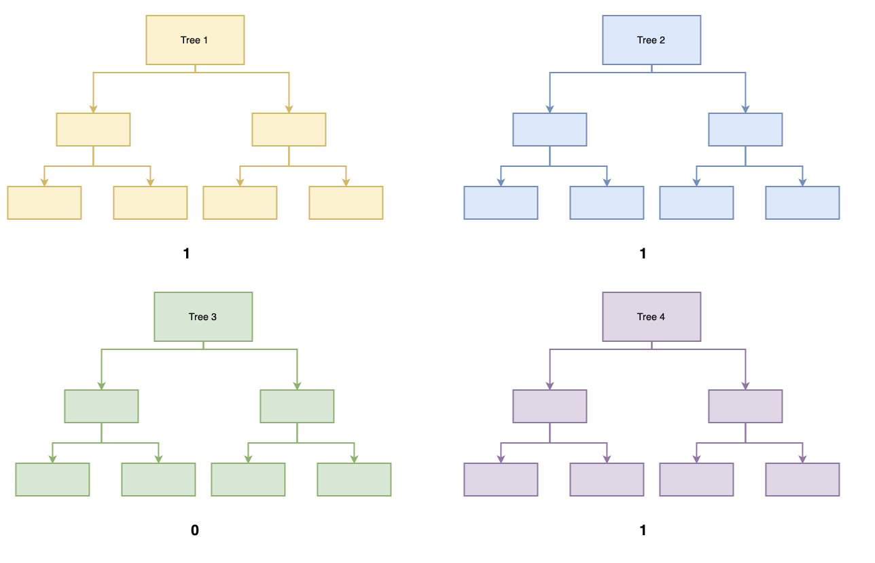

Diagram 1: Example of a random forest. Three of the four are classified to 1, hence the data in question will be classified as group 1.

Two models were run, one with all variables included, and another with the limited variables from model 2. The full model iterated over 500 trees, with 6 variables per tree. The limited model also iterated over 500 trees, but only accounted for a single variable per tree due to the limited number of variables inputted. All three variables for the limited model (HIV/AIDs, income, and adult mortality) were all determined to be significant variables, while the full model considered in addition schooling to be a significant factor.

Reviewing the plots, the full vs. limited models were able to explain 90% and 88%, respectively, of life expectancy. Notice that the increase from 84% to 88% is significant considering the variables were not changed. This difference can be accounted to be due to the random forest algorithm.

### Comparing Competing Models

As the model complexity increases from simple linear regression, to regression with interaction terms, and finally random forest, the model’s ability to explain life expectancy increases from 73% to 90%. While there is an increase in the mean squared error for model 2 and 3 (3.50 to 7.51, respectively), the increase in the R2 is significant. The increase in residual error for the random forest may be due to the algorithm’s nature of iterating through all variables and the 500 trees.

|  |  |  |
| --- | --- | --- |
| **Models** | **MSE** | **AdjR2** |
| Model 1 | 4.34 | 0.73 |
| Model 2 | 3.50 | 0.84 |
| Model 3 | 7.51 | 0.90 |

Table 4: Regression metrics comparison for the three models (simple, complex, and random forest).

Model 1 is the simplest of the three, with an intermediate mean squared error (MSE) and decent ability to explain life expectancy data. Model 2 has the lowest MSE at 3.5, with the ability to explain 84% of the data. While model 2 is an increase in complexity from model 1, the additional variables and interaction terms result in a 0.09 increase in R2. Finally, model 3 has the highest MSE, and also the highest explanatory ability of 90%, but is the most complex of all three models. Arguably, model 2 may be the most balanced of the three when considering interpretability, MSE, explanatory ability, and weights of bias and precision.

### Conclusion

All three models are capable of explaining greater than 70% of the life expectancy data. Model 1 has the greatest interpretability, with a moderate MSE (4.34) by including only income and composition of resources in a linear regression. Model 2 increases complexity by introducing additional variables (adult mortality, HIV/AIDs) and an interaction term (where income and HIV/AIDs are dependent on one another). The model has the lowest MSE (3.5) of all three models, while having the explanatory ability of 84%, also through linear regression. Model 3 is the most complex of all the models, using the random forest algorithm. While maintaining the highest explanatory ability of 90%, model 3 also has the highest MSE of 7.51 when including all variables.

Model 2 is the recommended model for all metrics (interpretability, error, etc…). Model 2 is relatively simple in comparison to random forest, and has an explanatory model that is considered sufficient. The model also is not as biased as model 1 (with only one variable) and more precise than model 3 (all variables imputed to the algorithm), providing a balance between the two.

The study is observational, hence no cause-and-effect can be determined. A concern with the data set is the missing information. There appears to be missing columns concerning smoking and other factors that may have been beneficial to the analysis. In addition, the data is only analyzed for the year 2014. Additional analysis on each year may provide additional insights.

# 

# Appendix

Well commented SAS/R Code

Graphics and summary tables (Can be placed in the appendix or in the written report itself.)

## Data

### Data Definitions

|  |  |
| --- | --- |
| **Variable** | **Definition** |
| Year | Year |
| Status | Developed or Developing status |
| Life expectancy | Life expectancy in Age |
| Adult Mortality | Adult Mortality Rates of both sexes (probability of dying between 15 and 60 years per 1000 population) |
| Infant deaths | Number of Infant Deaths per 1000 population |
| Alcohol | Alcohol, recorded per capita (15+) consumption (in litres of pure alcohol) |
| percentage expenditure | Expenditure on health as a percentage of Gross Domestic Product per capita(%) |
| Hepatitis B | Hepatitis B (HepB) immunization coverage among 1-year-olds (%) |
| Measles | Measles - number of reported cases per 1000 population |
| BMI | Average Body Mass Index of entire population |
| Polio | Polio (Pol3) immunization coverage among 1-year-olds (%) |
| Total expenditure | General government expenditure on health as a percentage of total government expenditure (%) |
| Diphtheria | Diphtheria tetanus toxoid and pertussis (DTP3) immunization coverage among 1-year-olds (%) |
| HIV/AIDS | Deaths per 1 000 live births HIV/AIDS (0-4 years) |
| GDP | Gross Domestic Product per capita (in USD) |
| Population | Population of the country |
| thinness 1-19 years | Prevalence of thinness among children and adolescents for Age 10 to 19 (%) |
| thinness 5-9 years | Prevalence of thinness among children for Age 5 to 9(%) |
| income composition of resources | Human Development Index in terms of income composition of resources (index ranging from 0 to 1) |
| schooling | Number of years of Schooling(years) |

## Objective 1

### Model 1

#### Model Selections

##### Forward

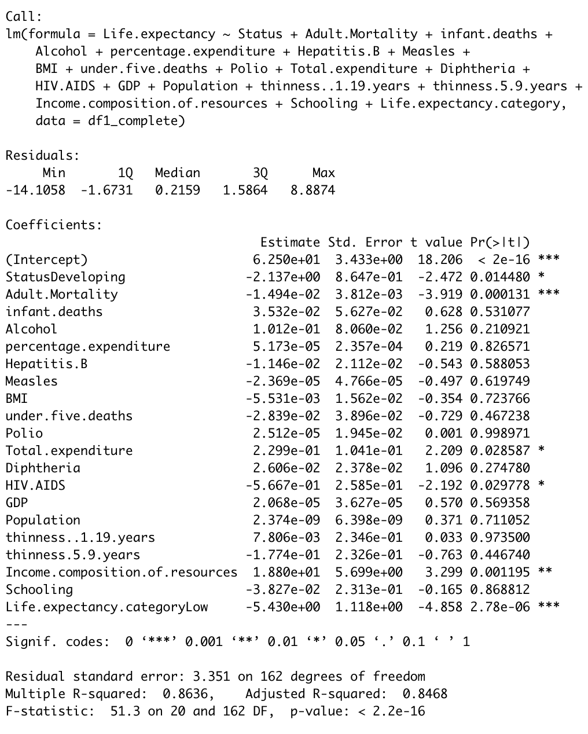

##### Stepwise

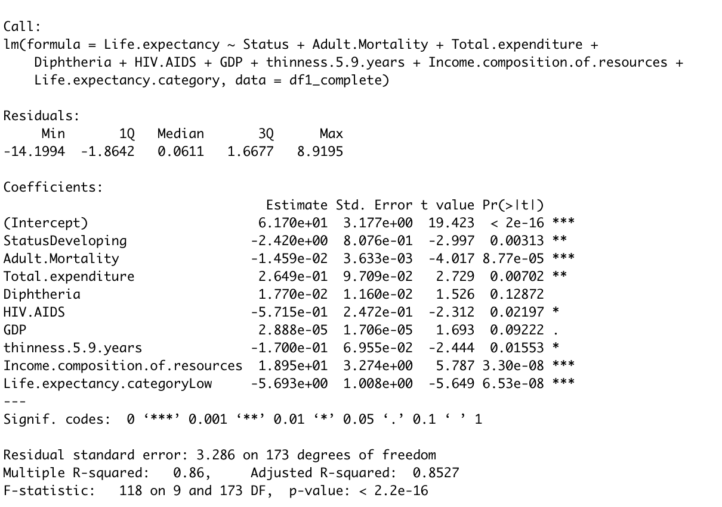

##### Lasso

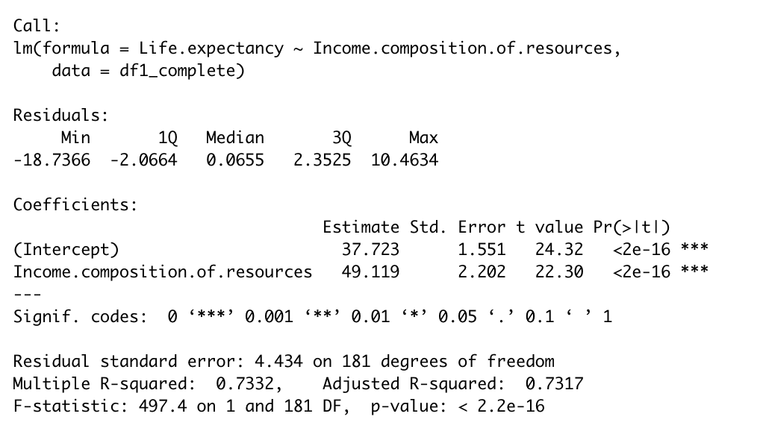

#### Assumptions

|  |  |  |  |
| --- | --- | --- | --- |
| **Models/Graphs** | **Forward** | **Backward/Stepwise** | **Lasso** |
| Linearity |  | | |
| Constant Variance |  |  |  |
| Normality |  |  |  |
| Outliers |  |  |  |
| Independence | No evidence against | No evidence against | No evidence against |

### Model 2

#### Interaction Term Model

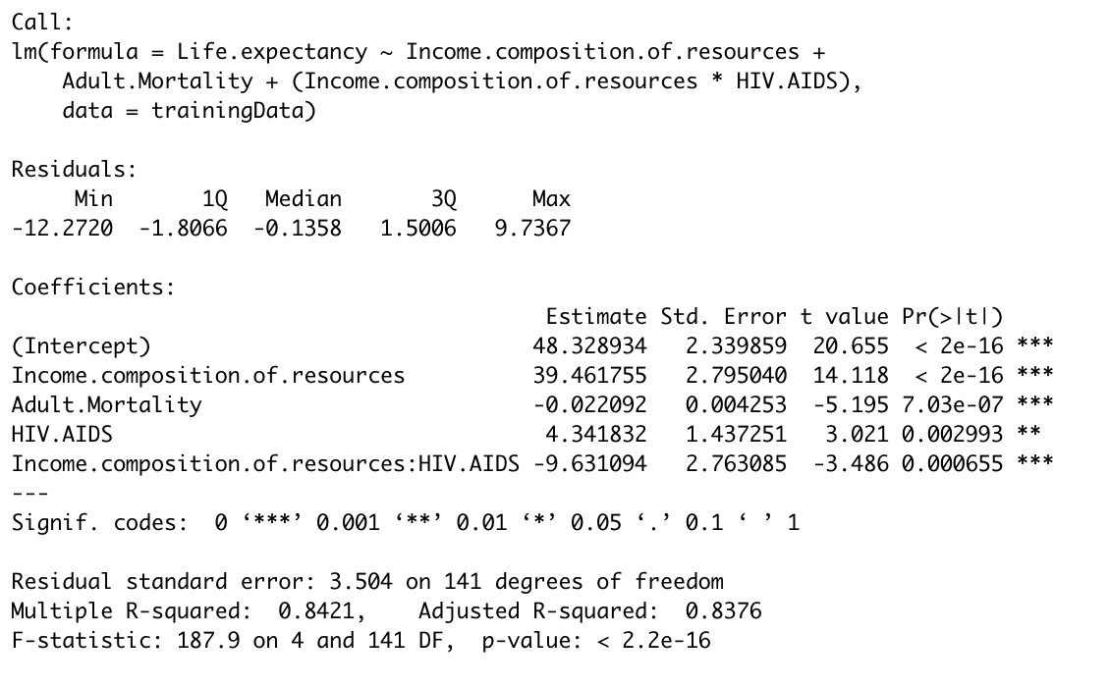

#### Assumptions

|  |  |
| --- | --- |
| Assumption | Graph |
| Linearity |  |
| Normality |  |
| Constant Variance |  |
| Independence | No evidence against |
| Cook’s D |  |

### Confidence Intervals

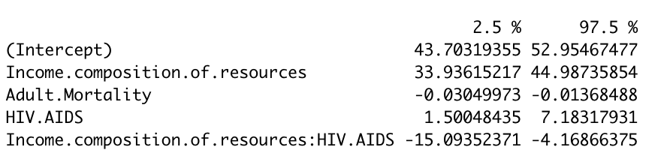

## Objective 2

### Random Forest Regression Tree

#### Full Model

##### Metrics

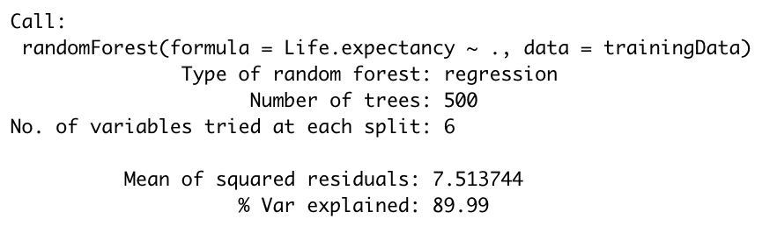

##### Variable Analysis

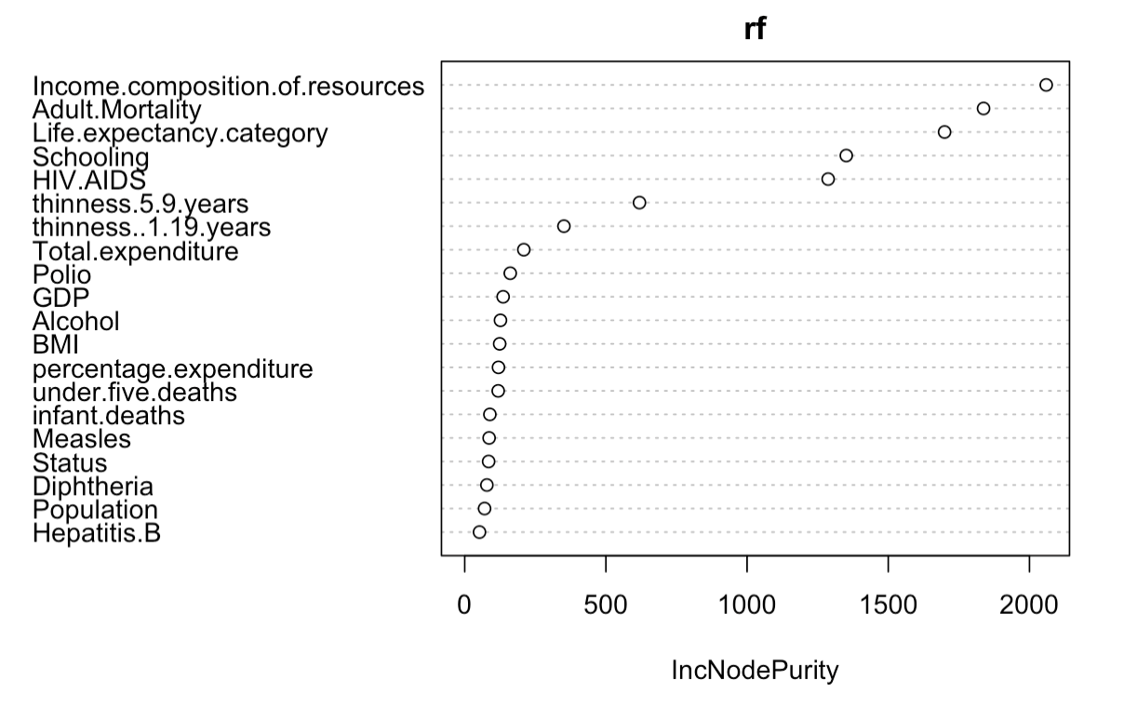

##### Error Trend

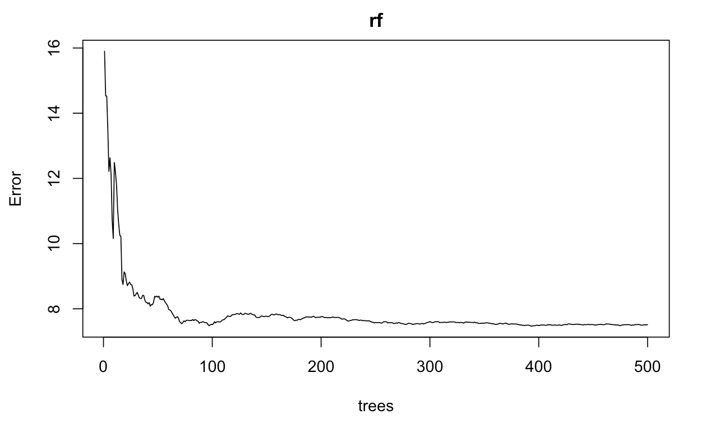

#### Limited Variables Model

##### Metrics

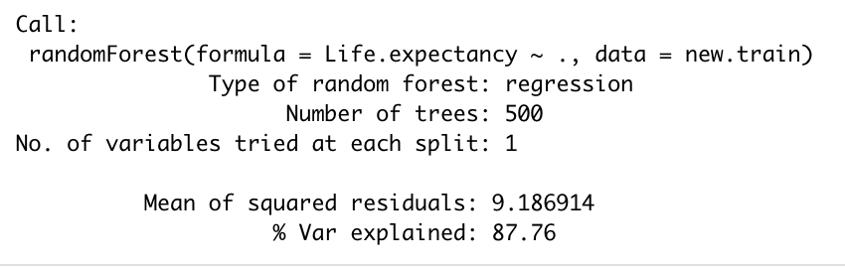

##### Variable Analysis

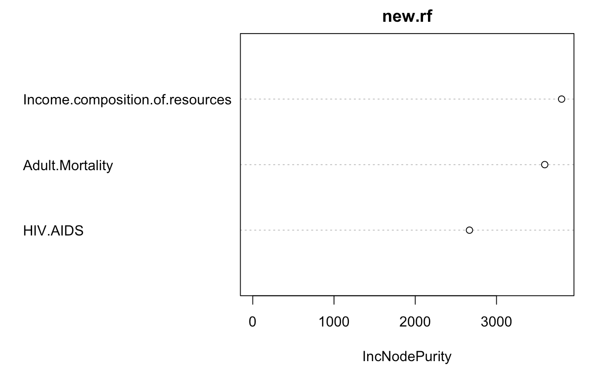

##### Error Trend

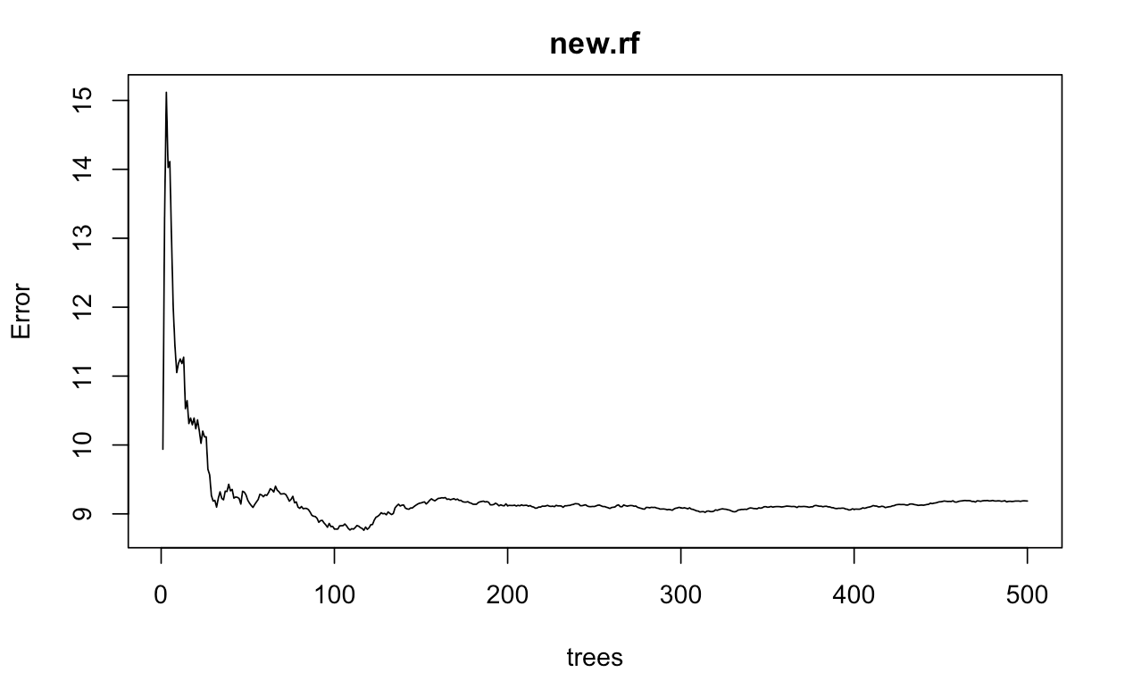

## R Code:

```{r setup, include=FALSE}

knitr::opts_chunk$set(echo = FALSE, message = FALSE, warning = FALSE)

library(ggplot2)

library(plyr)

library(dplyr)

library(GGally)

library(tidyverse)

library(naniar)

library(zoom)

library(MASS)

library(plotly)

library(ggpubr)

library(glmnet)

library(randomForest)

library(DAAG)

library(forecast)

```

```{r}

# creates all required residual plots

residual.plots <- function (model) {

par(mfrow = c(2, 3))

p1 <- plot(model)

p2 <- plot(model, 3)

p3 <- plot(model, 4)

return(list(p1, p2, p3))

}

# Compute R^2 from true and predicted values

eval_results <- function(true, predicted, df) {

SSE <- sum((predicted - true)^2)

SST <- sum((true - mean(true))^2)

R_square <- 1 - SSE / SST

RMSE = sqrt(SSE/nrow(df))

# Model performance metrics

data.frame(

RMSE = RMSE,

Rsquare = R_square

)

}

```

```{r}

# Reading datafile

Life_Expectancy_Df <- Life_Expectancy_Df <- read.csv("../data\ /Life\ Expectancy\ Data.csv", header=TRUE)

Life_Expectancy_Df_2014 <- Life_Expectancy_Df %>% filter(Year == 2014) # Keeping only 2014 data as per requirement

gg_miss_var(Life_Expectancy_Df_2014)

# replace missing data with averages

df_means <- Life_Expectancy_Df_2014

for(i in 1:ncol(df_means)){

df_means[is.na(df_means[,i]), i] <- mean(df_means[,i], na.rm = TRUE)

}

sum(is.na(df_means))

df1_complete <- df_means[,c(3:22)]

#df_means.condense <- df_means.condense %>% filter(df_means.condense$percentage.expenditure < 100)

# Adding a column to categorize Life.expectancy as >= 65 and < 65 for comparison

Life.expectancy.category=ifelse(df1_complete$Life.expectancy >= 65.0,"High","Low")

df1_complete =data.frame(df1_complete ,Life.expectancy.category)

```

#### 1. Does various predicting factors which has been chosen initially really affect the Life expectancy? What are the predicting variables actually affecting the life expectancy?

```{r}

# Fit the full model

full.model <- lm(Life.expectancy ~., data = df1_complete)

# Stepwise regression model

step.model <- stepAIC(full.model, direction = "both",

trace = FALSE)

summary(step.model)

AIC(step.model)

residual.plots(step.model)

plot(Life.expectancy ~., data = df1_complete)

abline(step.model)

# forward regression model

foward.model <- stepAIC(full.model, direction = "forward",

trace = FALSE)

summary(foward.model)

residual.plots(foward.model)

# backward regression model

backward.model <- stepAIC(full.model, direction = "backward",

trace = FALSE)

summary(backward.model)

CV(backward.model)

residual.plots(backward.model)

# assumptions testing

par(mfrow = c(2, 2))

residual.plots(full.model)

```

#### 2.Should a country having a lower life expectancy value(<65) increase its healthcare expenditure in order to improve its average lifespan?

```{r}

#2-sample t-test for Life Expectancy value:

res.total.expenditure <- t.test(Total.expenditure ~ Life.expectancy.category , data = df1_complete, var.equal = TRUE)

res.total.expenditure

# Fitting the tree model for classifying life expectancy value based on healthcare expenditure

df1_complete$Life.expectancy.category <- as.factor(df1_complete$Life.expectancy.category)

healthcare.expenditure.tree <- tree(formula = Life.expectancy.category ~ Total.expenditure, data = df1_complete)

# summary statistics of healthcare.expenditure.model for life expectancy

summary(healthcare.expenditure.tree)

plot(healthcare.expenditure.tree)

```

#### 3.How does Infant and Adult mortality rates affect life expectancy?

```{r}

#Fitting Adult.Mortality model

Adult.Mortality.model <- lm(Life.expectancy ~Adult.Mortality, data = df1_complete)

summary(Adult.Mortality.model)

# graph the regession

p.Adult.Mortality <- ggplot(df1_complete, aes(x = Adult.Mortality , y = Life.expectancy )) + geom_point() + stat_smooth(method = "lm", col = "red")

ggplotly(p.Adult.Mortality)

# assumptions testing

par(mfrow = c(2, 2))

plot(Adult.Mortality.model)

#Fitting model for both Adult.Mortality and Infant death

Adult.infant.model <- lm(Life.expectancy ~Adult.Mortality+infant.deaths, data = df1_complete)

summary(Adult.infant.model)

# assumptions testing

par(mfrow = c(2, 2))

plot(Adult.infant.model)

```

#### 4.Does Life Expectancy has positive or negative correlation with eating habits, lifestyle, exercise, smoking, drinking alcohol etc.

```{r}

#Fitting BMI model

BMI.model <- lm(Life.expectancy ~BMI, data = df1_complete)

summary(BMI.model)

# graph the regession

p.BMI <- ggplot(df1_complete, aes(x = BMI , y = Life.expectancy )) + geom_point() + stat_smooth(method = "lm", col = "red")

ggplotly(p.BMI)

# assumptions testing

par(mfrow = c(2, 2))

plot(BMI.model)

```

#### 5.What is the impact of schooling on the lifespan of humans?

```{r}

# linear model

school.model <- lm(Life.expectancy ~Schooling, data = df1_complete)

# summary statistics of schooling vs. life expectancy

summary(school.model)

# graph the regession

p.school <- ggplot(Life_Expectancy_Df_2014, aes(x = Schooling , y = Life.expectancy )) + geom_point() + stat_smooth(method = "lm", col = "red")

ggplotly(p.school)

# assumptions testing

par(mfrow = c(2, 2))

plot(school.model)

```

#### 6.Does Life Expectancy have positive or negative relationship with drinking alcohol?

```{r}

# linear model

alcohol.model <- lm(Life.expectancy ~Alcohol, data = df1_complete)

# summary statistics of schooling vs. life expectancy

summary(alcohol.model)

# graph the regession

p.alcohol <- ggplot(Life_Expectancy_Df_2014, aes(x = Alcohol , y = Life.expectancy )) + geom_point() + stat_smooth(method = "lm", col = "red")

ggplotly(p.alcohol)

par(mfrow = c(2, 2))

plot(alcohol.model)

```

#### 7.Do densely populated countries tend to have lower life expectancy?

```{r}

# linear model

popultion.model <- lm(Life.expectancy ~Population, data = df1_complete)

# summary statistics of schooling vs. life expectancy

summary(popultion.model)

# graph the regession

p.population <- ggplot(Life_Expectancy_Df_2014, aes(x = Population , y = Life.expectancy )) + geom_point() + stat_smooth(method = "lm", col = "red")

ggplotly(p.population)

# assumptions testing

par(mfrow = c(2, 2))

plot(popultion.model)

# remove the outlier

attach(df1_complete)

# sort by mpg

newdata <- df1_complete %>% arrange(desc(Population))

# drop outlier

newdata = newdata[-1,]

# linear model

popultion.model2 <- lm(Life.expectancy ~Population, data = newdata)

# summary statistics of schooling vs. life expectancy

summary(popultion.model2)

# graph the regession

p.population2 <- ggplot(newdata, aes(x = Population , y = Life.expectancy )) + geom_point() + stat_smooth(method = "lm", col = "red")

ggplotly(p.population2)

# assumptions testing

par(mfrow = c(2, 2))

plot(popultion.model2)

```

#### 8.What is the impact of Immunization coverage on life Expectancy?

#Reviewing the graphs, there does not appear to be a significant relationship between life expectancy and immunization.

```{r}

# 1. LINEAR REGRESSION

# list of immunizations

df_immunizations <- df1_complete %>% select("Life.expectancy", "Hepatitis.B", "Polio", "Diphtheria")

# linear model

immunization.model <- lm(Life.expectancy ~., data = df_immunizations)

# summary statistics of schooling vs. life expectancy

summary(immunization.model)

# graph the regession

require(gridExtra)

p1 <- ggplot(Life_Expectancy_Df_2014, aes(x = Hepatitis.B , y = Life.expectancy )) + geom_point()

p2 <- ggplot(Life_Expectancy_Df_2014, aes(x = Polio , y = Life.expectancy )) + geom_point()

p3 <- ggplot(Life_Expectancy_Df_2014, aes(x = Diphtheria , y = Life.expectancy )) + geom_point()

grid.arrange(p1, p2, p3, ncol=2)

# assumptions testing

residual.plots(immunization.model)

# 2. LOG TRANSFORMATIONS

# create logged transformations

df_immunizations$log.Life.expectancy <- log(df_immunizations$Life.expectancy)

df_immunizations$log.Hepatitis.B <- log(df_immunizations$Hepatitis.B)

# log-log linear model

log.immunization.model <- lm(log.Life.expectancy ~log.Hepatitis.B, data = df_immunizations)

# summary statistics

summary(log.immunization.model)

# graph regression

ggplot(df_immunizations, aes(x = log.Hepatitis.B , y = log.Life.expectancy )) + geom_point()

# residual plots

residual.plots(log.immunization.model)

# 3. POLYNOMIAL REGRESSION TESTING

# linear model

ploy.immunization.model <- lm(Life.expectancy ~Hepatitis.B+I(Hepatitis.B^2), data = df_immunizations)

# summary statistics

summary(ploy.immunization.model)

AIC(ploy.immunization.model)

BIC(ploy.immunization.model)

# graph regression

ggplot(df_immunizations, aes(x = Hepatitis.B , y = Life.expectancy )) + geom_point() + stat_smooth(method = "loess", formula = y ~ x, size = 1) + ggtitle("Life Expectancy vs. Heptatitis B with trend line")

ggplot(df_immunizations, aes(x = Hepatitis.B , y = Life.expectancy )) + geom_point() + stat_smooth(method = "lm", formula = y ~ x + I(x^2), size = 1) + ggtitle("Life Expectancy vs. Heptatitis B with quadratic regression line")

# residual plots

residual.plots(ploy.immunization.model)

```

```{r}

# LASSO

## set the seed to make your partition reproducible

smp_size <- floor(0.5 * nrow(df1_complete))

set.seed(1234)

index <- sample(seq_len(nrow(df1_complete)), size = smp_size)

train<-df1_complete[index,]

test<-df1_complete[-index,]

#Formatting data for GLM net

x=model.matrix(Life.expectancy~.,train)[,-1]

y=(train$Life.expectancy)

xtest<-model.matrix(Life.expectancy~.,test)[,-1]

ytest<-(test$Life.expectancy)

grid=10^seq(10,-2, length =100)

lasso.mod=glmnet(x,y,alpha=1, lambda =grid)

cv.out=cv.glmnet(x,y,alpha=1) #alpha=1 performs LASSO

plot(cv.out)

bestlambda<-cv.out$lambda.min #Optimal penalty parameter. You can make this call visually.

lasso.pred=predict(lasso.mod ,s=bestlambda ,newx=xtest)

testMSE_LASSO<-mean((ytest-lasso.pred)^2)

testMSE_LASSO

# review coefficients

coef(lasso.mod,s=bestlambda)

# plot variable analysis

plot(lasso.mod,xvar="lambda",label=TRUE)

# review R^2 results

eval_results(ytest, lasso.pred, test)

# Fit linear regresion to model

lasso.linear.model <- lm(Life.expectancy ~Income.composition.of.resources, data = df1_complete)

summary(lasso.linear.model)

residual.plots(lasso.linear.model)

ggplot(df1_complete, aes(x = Income.composition.of.resources , y = Life.expectancy )) + geom_point() + stat_smooth(method = "loess", formula = y ~ x, size = 1) + ggtitle("Life Expectancy vs. Income with trend line")

ggplot(df1_complete, aes(x = Income.composition.of.resources , y = Life.expectancy )) + geom_point() + stat_smooth(method = "lm", formula = y ~ x, size = 1) + ggtitle("Life Expectancy vs. Income with regression line")

```

2. Report predictive ability

a. Test/train set

b. CV data

```{r}

# Create Training and Test data -

set.seed(100) # setting seed to reproduce results of random sampling

trainingRowIndex <- sample(1:nrow(df1_complete), 0.8*nrow(df1_complete)) # row indices for training data

trainingData <- df1_complete[trainingRowIndex, ] # model training data

testData <- df1_complete[-trainingRowIndex, ] # test data

# Build the model on training data -

lmMod <- lm(Life.expectancy ~Income.composition.of.resources, data=trainingData) # build the model

distPred.confidence <- predict(lmMod, testData, interval = 'confidence', level=0.95) # predict distance

distPred.prediction <- predict(lmMod, testData, interval = 'prediction') # predict distance

confint(lmMod)

summary (lmMod) # model summary

# accuracy statistics

actuals_preds <- data.frame(cbind(actuals=testData$Life.expectancy, predicteds=distPred.confidence)) # make actuals_predicteds dataframe.

correlation_accuracy <- cor(actuals_preds) # 82.7%

AIC(lmMod)

BIC(lmMod)

CV(lmMod)

predict(lmMod, testData, interval="confidence")

```

Comparing the models

```{r}

#train/test all models

train.full.model <- lm(Life.expectancy ~., data = trainingData)

# Stepwise regression model

trian.step.model <- stepAIC(train.full.model, direction = "both",

trace = FALSE)

distPred <- predict(trian.step.model, testData)

actuals_preds <- data.frame(cbind(actuals=testData$Life.expectancy, predicteds=distPred)) # make actuals_predicteds dataframe.

correlation_accuracy <- cor(actuals_preds)

# Forward regression model

trian.for.model <- stepAIC(train.full.model, direction = "forward",

trace = FALSE)

distPred.for <- predict(trian.for.model, testData)

actuals_preds.for <- data.frame(cbind(actuals=testData$Life.expectancy, predicteds=distPred.for)) # make actuals_predicteds dataframe.

correlation_accuracy.for <- cor(actuals_preds.for)

summary(lasso.linear.model)

# dataframe to hold all metrics

df.models1 <- data.frame(Models=c('forward', 'stepwise', 'lasso'))

df.models1$CV <- c(CV(foward.model)[[1]],CV(step.model)[[1]], CV(lasso.linear.model)[[1]])

df.models1$AIC <- c(CV(foward.model)[[2]],CV(step.model)[[2]], CV(lasso.linear.model)[[2]])

df.models1$BIC <- c(CV(foward.model)[[4]],CV(step.model)[[4]], CV(lasso.linear.model)[[4]])

df.models1$AdjR2 <- c(CV(foward.model)[[5]],CV(step.model)[[5]], CV(lasso.linear.model)[[5]])

df.models1$Accuracy <- c(0.78,0.79, 0.76)

```

5. Confidence intervals

```{r}

distPred.confidence <- predict(lmMod, testData, interval = 'confidence', level=0.95) # predict distance

distPred.prediction <- predict(lmMod, testData, interval = 'prediction') # predict distance

confint(lmMod)

```

6. Practical and statistical significance

The income index is the most significant predictor for life expectancy, explaining more than 70% of the data.

### Model 2

- Product the best predictions as possible

- Interpretation is no longer required, hence complexity is no longer an issue

1. Feature selection to avoid overfitting

A. Linear Regression

- model a: linear regression

life expectancy = 36.55 + 50.73(income)

Adjusted R^2 = 0.79

- model b: linear regression + adult mortality

life expectancy = 48.5 + 38.77(income) - 0.025 (adult mortality)

Adjusted R^2 = 0.84

- model c: linear regression + adult mortality + HIV.AIDS

life expectancy = 49.8 + 36.05 (income) - 0.016 (adult mortality) - 0.95 (HIV/AIDS)

Adjusted R^2 = 0.85

B. Interaction Terms

- model d: linear regression + adult mortality + HIV.AIDS

```{r}

# Lasso model lasso.mod determined that income the primary predictor for life expectancy

# SIMPLE MODEL

simple.model <- lm(Life.expectancy ~Income.composition.of.resources, data = df1_complete)

# Stepwise regression model

simple.step.model <- stepAIC(simple.model, direction = "both",

trace = FALSE)

summary(simple.step.model)

# ADDITION OF VARIABLES MODEL

# adult mortality

simple.model <- lm(Life.expectancy ~Income.composition.of.resources + Adult.Mortality , data = df1_complete)

summary(simple.model)

# Thinness

df.expenditure <- df1_complete %>% filter(df1_complete$percentage.expenditure < 100)

simple.model <- lm(Life.expectancy ~Income.composition.of.resources + Adult.Mortality + Total.expenditure, data = df.expenditure)

summary(simple.model)

# AIDS

simple.model <- lm(Life.expectancy ~Income.composition.of.resources + Adult.Mortality + HIV.AIDS, data = df1_complete)

summary(simple.model)

# Interaction terms

simple.model <- lm(Life.expectancy ~Income.composition.of.resources + Adult.Mortality + HIV.AIDS + (Adult.Mortality*HIV.AIDS) + (Income.composition.of.resources*Adult.Mortality) +(Income.composition.of.resources*HIV.AIDS), data = df1_complete)

summary(simple.model)

```

2. Create the model

```{r}

complex.model <- lm(Life.expectancy ~Income.composition.of.resources + Adult.Mortality +(Income.composition.of.resources*HIV.AIDS), data = trainingData)

summary(complex.model)

residual.plots(complex.model)

```

3. Compare model 1 vs. model 2

```{r}

distPred.complex <- predict(complex.model, testData)

actuals_preds.complex <- data.frame(cbind(actuals=testData$Life.expectancy, predicteds=distPred.complex)) # make actuals_predicteds dataframe.

correlation_accuracy.complex <- cor(actuals_preds.complex)

confint(complex.model)

df.models <- data.frame(Models=c('model1', 'model2'))

df.models$CV <- c(CV(lasso.linear.model)[[1]], CV(complex.model)[[1]])

df.models$AIC <- c( CV(lasso.linear.model)[[2]], CV(complex.model)[[2]])

df.models$BIC <- c(CV(lasso.linear.model)[[4]], CV(complex.model)[[4]])

df.models$AdjR2 <- c(CV(lasso.linear.model)[[5]], CV(complex.model)[[5]])

df.models$Accuracy <- c( 0.76, 0.85)

print(df.models)

```

4. Comment on the differences of the models and whether model 2 brings any benefit

We notice that model 2 (the more complex of the two models) has a lower CV PRESS and higher adjusted R2. While model 1 is simple to comprehend, model 2 has higher predictability powers.

## Objective 2

- Nonparametric technique

- kNN or regression trees (select one)

Set of predictors from previous regression: (fill this out)

1. Model

```{r}

# RANDOM FOREST

# all variables

rf <- randomForest(

Life.expectancy ~ .,

data=trainingData

)

varImpPlot(rf)

pred = predict(rf, newdata=testData)

pred.df <- as.data.frame(pred)

pred.df$true <- testData$Life.expectancy

pred.df$idu <- as.numeric(row.names(pred.df))

ggplot() + geom_point(data=pred.df, aes(x = idu, y = true ), color='blue')+ geom_point(data=pred.df, aes(x = idu, y = pred ), color='red')

plot(rf)

print(rf)

# limited variables

new.train <- trainingData %>% select(Adult.Mortality,HIV.AIDS, Income.composition.of.resources, Life.expectancy)

new.test <- testData %>% select(Adult.Mortality,HIV.AIDS, Income.composition.of.resources, Life.expectancy)

new.rf <- randomForest(

Life.expectancy ~ .,

data=new.train

)

varImpPlot(new.rf)

new.pred <- predict(new.rf, newdata=new.test)

new.pred.df <- as.data.frame(new.pred)

new.pred.df$true <- new.test$Life.expectancy

new.pred.df$idu <- as.numeric(row.names(new.pred.df))

ggplot() + geom_point(data=new.pred.df, aes(x = idu, y = true ), color='blue')+ geom_point(data=new.pred.df, aes(x = idu, y = pred ), color='red')

plot(new.rf)

print(new.rf)

new.rf$confusion

class.error

```